**COAL LAB 12**

**21k4834**

**TASK 1**

#include <stdio.h>

unsigned long ThreeProd(unsigned short n1, unsigned short n2, unsigned short n3) {

unsigned long result;

_asm {

mov eax, 0

mov ax, n1

mov bx, n2

mul bx

mov bx, n3

mul bx

mov result, eax

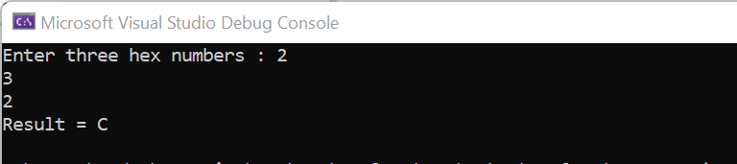

}

return result;

}

int main()

{

unsigned short n1, n2, n3;

unsigned long result;

printf("Enter hexadecimal numbers : ");

scanf_s("%hX %hX %hX", &n1, &n2, &n3);

result = ThreeProd(n1, n2, n3);

printf("Result = %X\n", result);

return 0;

}

**TASK 2**

#include <stdio.h>

unsigned long gcd(unsigned long n1, unsigned long n2) {

unsigned long GCD;

_asm {

start:

cmp n1, 0

jz end1

cmp n2, 0

jz end2

mov eax, n1

cmp eax, n2

jz end3

jl reccur1

jg reccur2

end1 :

mov eax, n2

mov GCD, eax

jmp endd

end2 :

mov eax, n1

mov GCD, eax

jmp endd

end3 :

mov eax, n1

mov GCD,eax

jmp endd

reccur1 :

mov eax, n2

sub eax, n1

mov n2, eax

jmp start

reccur2 :

mov eax, n1

sub eax, n2

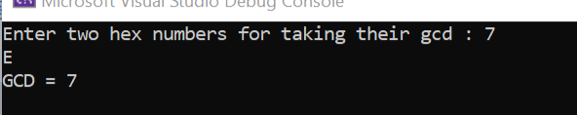

mov n1, eax

jmp start

endd :

}

return GCD;

}

int main()

{

unsigned long n1, n2;

unsigned long GCD;

printf("Enter two hex numbers for taking their gcd : ");

scanf_s("%lx %lx", &n1, &n2);

GCD = gcd(n1, n2);

printf("GCD = %lX\n", GCD);

}